# The effects of financial stress on the Swedish economy

Andreas Timoudas

Department of Economics, Stockholm University

Spring 2022



**Abstract**

*Keywords: Macroeconomics, Time-series*

**Acknowledgements**

# 1 Introduction

Historically there have been several financial crisis affecting the Swedish economy, the most notorious in recent years being the Swedish banking crisis in the 1990s, the dotcom bubble in the 2000s and the global financial crisis 2007. These kind of events are often build up for some time before their unraveling and are usually unexpected and severe for the general public.

Functioning banking institutions and financial markets require financing, trust and capital to operate in normal conditions. When Lehman Brothers went bankrupt in 2008, uncertainty and financial stress spread globally, as fire sales destroyed asset values when people pulled their money from the financial markets and banks, since no one knew what might collapse next. To backstop and try to restore trust the Troubled Asset Relief Program (TARP) was passed in the US while in Sweden, the crisis fortunately remained a liquidity crisis, still forcing the Swedish central bank, the Riksbank, to lower interest rates and increase it’s balance sheet up to three times to the following year, to stabilize the situation.

It is reasonable to believe that financial stress has an effect on the real economy, as uncertainty and distress creates an unpredictable environment. In this type of environment economists agree that it holds back business investments and household consumption. Since there are real economic consequences of financial stress, monitoring financial stability has become increasingly more important for central banks as well as the development of macroprudencial economic policies which are aiming at ensuring financial stability and prevent disruption.

The question this study aims to shed light on is how a small open economy as Sweden would be affected by a shock to financial stress and what connection there is between financial stress and macroeconomic variables such as GDP growth, inflation, and interest rates. This study has its base to study the dynamics between these variables, because there are different ways to define financial stress and to which extent it affects the economy.

I have chosen to limit this study to the Swedish economy as I noticed there are few studies about how financial stress affects the Swedish economy. This study is executed by using a Bayesian mean-adjusted VAR-model proposed by Villani (2009). The contribution of this study lies in explaining how the Swedish economy is affected by a shock to financial stress from the chosen variable over the time during the period 1995-2021.

I found that a positive shock to financial stress significantly reduces GDP growth up to five quarters after the shock, where the highest effect is a reduction of GDP growth with 0.41 percentage points while other economic variables had no significant response. [Varför är detta intressant egentligen?]

# 2 Previous literature

In this section, I briefly review previous literature on the topic of the thesis, focusing on studies examining the relationship between financial stress and uncertainty and the real economy.

Stockhammar & Osterholm (2014) studied the effect of the euro area shocks on the Swedish economy by using a mean-adjusted Bayesian VAR-model. The authors found that shocks to the euro area had considerable effect on Swedish GDP growth. Stockhammar & Osterholm (2014) also studied the effects of US policy uncertainty on Swedish GDP Growth, where policy uncertainty was measured as the policy uncertainty index developed by Baker et.al. (2013). Using a mean-adjusted Bayesian VAR-model showed that increased US policy uncertainty had significant negative effects on Swedish GDP growth, which according to the authors had its origin from effects on investment growth and export growth.

Utland & Roye (2010) conducted a study of the effects of external shocks on countries in emerging Asia using a BVAR model. They showed that almost half of the forecast error variance in emerging Asia’s real GDP growth could be explained by external factors. Roye (2011) constructed a financial market stress indicator (FMSI) for Germany and the euro area using a dynamic factor model to be used in a Bayesian VAR-model. Roye found that about fifteen percent of variation in real GDP growth could be accounted for variations in the FMSI, and 30 percent respectively for the euro area. He also showed that including the FMSI significantly improved out-of-sample forecasting accuracy for real GDP in Germany compared to other models.

Bjellerup & Shahanazarian (2012) developed a framework for the propagation of financial systems to the real economy. They investigated four channels of propagation, mainly interest rate, bank reserves, balance sheet, and uncertainty channel where the theory of propagation of each channel is that increased interest rates lead to higher credit costs and lower consumption and investments. Increased market, credit or financial risk depreciates banks balance sheet through lower asset prices which under bank capital reserve requirements can lead to lower credit expansion and higher interest rates for the bank to maintain profitability. Falling asset prices leading to depreciated balance sheets for firms and households which may lead to lower collateral values and tougher credit requirements which creates a feedback loop of lowering asset prices further. Lastly increased uncertainty in the form of increased volatility in asset pricing, leads to lower investments being made and lower consumption. Using a VAR model which included three propagation variables, a financial stress index for the uncertainty channel, repo rate and wealth gap to capture interest rate, banking and balance sheet propagations respectively, they found that a shock to the financial stress index reduced GDP growth significantly where a one percent increase in financial stress variable led to a negative response of 0.4 percent decrease of GDP-growth after two years.

Las´een (2020) studied the effects of monetary policy on economic activity and asset prices using an external instrument, mainly monetary policy surprises to identify monetary policy shocks and remove contemporaneous central bank information shocks. This method of external instruments in VAR models was introduced by Stock (2008) and has later been used more widely and seen as state of art. Las´een found that a tightening of monetary policy has significant effects by reducing economic activity and inflation. Further, he found that central bank information shocks do not bias the identification of monetary policy shocks in the Swedish case.

# 3 Financial Stress Index

Financial stress indices have been adopted by several financial organisations and central banks over the years as a tool to monitor financial conditions since financial systems play a central roll in the economy. For financial markets to function well, liquidity, trust and symmetric information is required so that participants can agree on fair prices. In distressed times, trust can deteriorate quickly and asset-values can can suddenly shift leading to lower levels of liquidity. Funding can become more difficult and expensive as risk premium increases and liquidity risk premium increases.

The Riksbanks FSI-index is calculated based of four sub-markets where there are three indicators for each sub-market. Each indicator is ranked by magnitude in relation to earlier observations as to increase the index’s ability to account for new information. The financial stress index is calculated as an equally-weighted mean value of the sub-market indicators, which are squared and adjusted with regards to the correlations between the sub-market indicators. (Johansson & Bonthron, 2013). As seen in Table 1 below, stress is measured in the form of factors such as volatility, spreads and valuation losses. These factors represent uncertainty about asset prices and flight to safe assets which can be considered important features of financial stress. Hakkio & Keeton (2009) describe the key features of financial stress as increased uncertainty of both fundamental value of assets, and investor behavior as well as unwillingness to hold illiquid and or risky assets.

Table 1: Sub-markets and indicators in the new stress index

SUB-MARKETS INDICATORS

|  |  |
| --- | --- |
| Stock market | Implied volatility  Market value in relation to the highest in 2 years  Estimated liquidity based on turnover data |
| Bond market | Difference between 5-year covered bond yield and 5-year swap rate Difference between 5-year covered bond yield and 5-year swap rate minus the 2-year equivalent  Difference between 5-year swap rate and 5-year government bond yield |
| Money market | Difference between 3-month Stibor rate and 3-month treasury bill yield (TED spread)  Historical volatility of TED spread  Difference between 3-month Stibor rate and 3-month implied Stibor rate |
| Foreign exchange market | Implied volatility of USD/SEK  Implied volatility of EUR/SEK  30 day change in the value of the krona against a basket of currencies  (TCW index) in absolute terms |

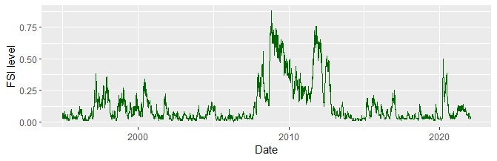

Figure 1: Financial Stress Index

# 4 Study Design

In this section I will cover the data used in the model, the recursive ordering which is used to identify the structural shocks and the steady state priors for all variables. The data consists of quarterly observations ranging from 1995 to 2021 with respect to four macroeconomic variables.

*xt* = (*SMSI y π* ∆*i*)*.* (1)

|  |  |  |
| --- | --- | --- |
| Variable | Description | Identifier |
| *SFSI* | Swedish Financial Stress Index | SFSI |
| *y* | Swedish GDP growth | BNP |
| *π* | Swedish inflation rate | CPI |
| ∆*i* | 3-month rate for Swedish treasury bills (first difference) | DINT |

Table 2: Caption

The SFSI data is originally daily observations that have been aggregated to quarterly observations. The remaining variables are seasonally adjusted and all data except the SFSI data has been obtained from the FRED database, while the SFSI index was provided by the Riksbank.

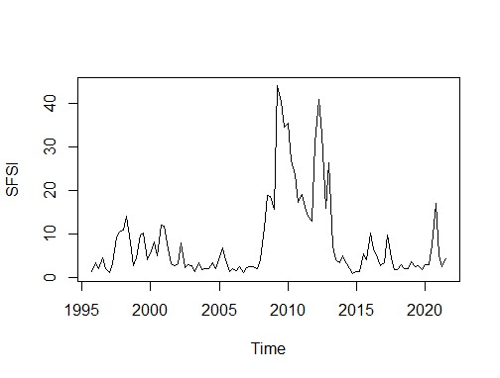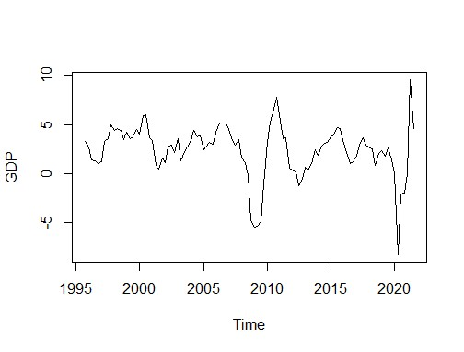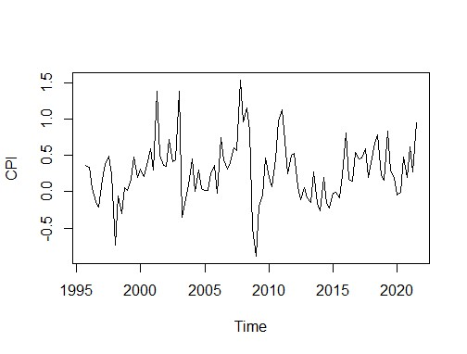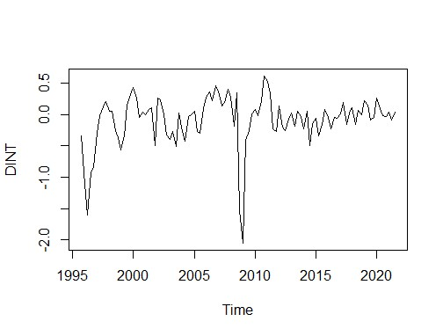

The steady state priors are chosen according to Section 6 with the intervals for the steady state priors are specified in Section 3. Since there is no theory on the prior for SFSI, I have imposed a rather diffuse prior with a wide distribution around the prior mean. For the steady state prior of Swedish GDP growth, I have used Villani (2009) and for inflation rate Beechey and Osterholm (2010). For the steady state prior for 3 months interest rate, I have set a prior around the zero mean since it is in first difference.

|  |  |  |  |  |
| --- | --- | --- | --- | --- |
|  | *SMSI* | *y* | *π* | ∆*i* |
| 95% prior probability interval | (2, 10) | (2, 2.5) | (0.2. 0.6) | (-0.5, 0.5) |

Table 3: Steady state priors

## 4.1 Identification

In this section I will present the different types of identification used in identifying structural shocks. Since the VAR model is estimated in its reduced form, shocks are correlated meaning all variables are contemporaneously dependent.

## 4.2 Choelesky identification

The Choelesky decomposition is a common way used to identify shocks as structural shocks, where the ordering of the variables is of importance. To order the variables one has to use economic reasoning and theory. In this model, the financial stress index is ordered first where the identifying assumption is that it affects GDP growth, inflation and interest rates and that the other variables do not affect the financial stress index in the same period but with a lag. In other words, the index is contemporaneously independent of all shocks but its own. Given the frequency of publishment of GDP and inflation data, it is not available for the markets in real term and thus cannot be acted upon or reflected in real time market variables. This ordering with the stress or uncertainty variable ordered first have been established in previous studies such as Bloom, (2009), Baker et al., (2012). The results from the Choelesky identification will serve as the main findings for the results in Section 7.

## 4.3 Sign restrictions

Sign restriction is another method to identify structural shocks. Given the economic theory we know, for example that positive demand shock increases both output and price while a positive supply shock increases output and decreases prices, this suggests that the sign or the set of values of the effect can be set given a positive shock on a variable in a VAR over a horizon. This approach of sign restrictions does not require a specific ordering of the variables as when using the Choelesky decomposition. Uhlig (2017) covers two principles on using sign restrictions, mainly to impose those restrictions you can reasonably impose.

I have identified four shocks in this paper, the main shock of interest being a positive financial stress shock, where the assumption is that an increase in financial stress lowers GDP growth and inflation rate by reducing investments and household consumption and increases interest rates as a reaction to lower inflationary environment. All identified shocks are presented in Table 4. While there is considerable previous literature and theory on sign restrictions for demand, supply and monetary policy, there is little for financial stress shocks. Commonly used strategies are to impose restriction based on results from a relevant DSGE model or base restrictions from theory. A requirement is that each shock is uniquely identified, meaning no other shock has the same set of restriction and if that is not the case, shocks can not be distinguished. To identify demand and supply and monetary policy shocks I have relied on Pearsman & Straub (2009) who uses results from a RBC model to use these to identify a VAR model using sign restrictions. Since a positive monetary policy shock represents a contraction in this paper, contrary to Pearsman & Straub (2009), signs are reversed. For financial stress using the theory laid out by Bjellerup & Shahanazarian (2012) briefly explained in Section 2, we set restrictions that a positive shock to financial stress reduces both GDP growth and inflation and increases overall uncertainty through feedback loops. To distinguish financial stress shocks from monetary policy shocks, restriction on interest rate change is made. Since contractionary monetary policy increases interest rates while a positive shock to financial stress which can be seen as an increase in uncertainty leads to less investments which results in a negative change of interest rates to stimulate investment growth. All restrictions are applied over a horizon of three periods.

|  |  |  |  |  |
| --- | --- | --- | --- | --- |
|  | Financial Stress | Demand | Supply | Monetary Policy |
| *SFSI y* | - | + | + | - |
| *π* | - | + | - | - |
| ∆*i* | - |  |  | + |

Table 4: Sign restrictions identification

# 5 Analysis

My empirical analysis is made in a Bayesian VAR framework using the Villani (2009) mean-adjusted model, which can be described in a general form as,

**Π**(*L*)(*xt* − *µ*) = *et,* (2)

where **Π(***L***)** = *I* − **Π**1*L* − *...* − **Π***mLm* is a lag polynomial of order *m*, *xt* is an *n* × 1 vector of stationary variables, *µ* is a *n* × 1 vector of unconditional means describing the steady state of the included variables, and *et* is a *n* × 1 vector *et* ∼ *N*(0*,*Σ) with *iid* elements.

The VAR framework was proposed by Sims (1980) as an alternative to complex macroeconomic models, since all variables are treated as endogenous in the VAR-model. This offers great flexibility but with the drawback that often a lot of parameters must be estimated depending on lag length. Since macroeconomic variables have relatively short sample size, we run the risk of over-parametrisation. One way to deal with this issue, as suggested by Litterman (1986), is to impose prior information on the parameters.

Villani (2009) proposed the mean-adjusted BVAR-model since he thought that all available priors for VARs focused on the dynamic coefficients, and for the most were non-informative about the deterministic component of the model. Villani’s adjustment of the BVAR-model allows to model the unconditional means of the variables, by setting the prior unconditional means of each variable explicitly. This is important as it is known that stationary VARs converge to the unconditional mean, at long horizons. The model will be identified recursively using standard Choelesky decomposition, and later with sign restrictions.

# 6 Priors

All parameters, *θ* in the model are treated as random variables in the Bayesian approach where *θ* = (**Π***,***Σ***,µ*) is given a prior distribution *π*(*θ*). It is then used to derive the posterior distribution *p*(*θ*|*Xt*) which is the distribution of the parameters given the observed data. The likelihood function is given by

*T*

*L*(*Xt*|*θ*) = Y*f*(*xt*|*Xt*−1*,θ*)*,* (3)

*t*=1

which is the distribution of the observed data given the parameters. Bayer’s rule tells us that the posterior distribution equals

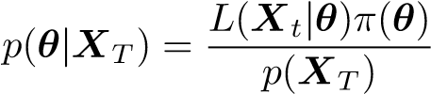*,* (4)

where *p*(*XT*) is the marginal likelihood. From this we see that the posterior depended on the data as well as any prior beliefs. In the case of no prior beliefs, [ADD] Villani (2009) shows normal-diffuse priors in the steady-state VAR are,

 (5)

*µ* ∼ *Nn*(*θµ,***Ω***µ*) (6)

*vec*(**Π**) ∼ *Nmn*2(*θ***Π***,***ΩΠ**) (7)

The prior distribution of the steady state *Nn*(*θµ,***Ω***µ*) is specified in [SECTION], while the distribution of the lag coefficients ∼ *Nmn*2(*θ***Π***,***ΩΠ**) is specified by the Minnesota prior beliefs (Litterman, 1986).

The Minnesota prior beliefs was introduced by Doan et al. (1984) and Litterman (1986) as a way to deal with the issue of over-parametrisation in VAR-models, by imposing tightness on the parameters and thus restricting the lag-structure. I follow Villiani’s (2009) slight modification of the Minnesota prior and set the prior mean of variables in first difference to 0, and 0.9 for variables in levels. Villani argued that since Littermens usual prior mean or unity for variables in levels is inconsistent with having a prior on the steady state. For the variance-covariance matrix of the coefficients **ΩΠ**, shrinkage hyperparameters *λ*1*,λ*2*,λ*3 are used to form the tightness on the lag structure. It’s specified as:

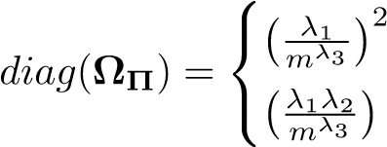for own lags

(8)

for lags of variable *q* in equation *r*

where the number of lags is denoted by *m*. The hyperparameters impose tightness according to Table 5.  is the variance of the residuals from as univariate

AR(m) estimation of for variable 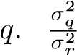 controls for differences in scale and units of measurement for the variables. The hyperparameters follow the standard practice of the Minnesota prior (Litterman, 1896).

Hyperparameter Description Value

|  |  |  |
| --- | --- | --- |
| *λ*1 | Overall Shrinkage | 0.2 |
| *λ*2 | Cross-variable Shrinkage | 0.5 |
| *λ*3 | Lag-decay | 1 |

Table 5: Minnesota hyperparameters

Villani (2009) states that the steady-state BVAR-model is untraceable, but that the distribution of each set of model parameters given the other parameters is traceable, and that a Gibbs sampler can be used to draw from the joint posterior.

In this study, I have used 10,000 draws using a Gibbs sampler.

# 7 Results

In this section results from the impulse response functions (IRF) will be presented and the historical decomposition for the structural shocks. Since the topic of this thesis is the effect of financial stress on the Swedish economy, only IRF’s regarding a shock to SFSI will be presented in this section. All IRF’s can be found in the Appendix in Figure 15.

The impulse response functions from a one standard deviation unit shock to the SFSI index are given in 3. We find that a shock the the SFSI has a significant effect on Swedish GDP growth, with a maximum effect of where growth is reduced with 0.41 percentage points. The effect of the shock goes to zero after five quarters. The other economic variables show no significant effect over the horizon. Inflation rate is reduced with a maximum effect of 0.12 percentage point were the effect disappears after 10 quarters. Since the 3-month interest rate is in first difference the effect is interpreted as the rate of change

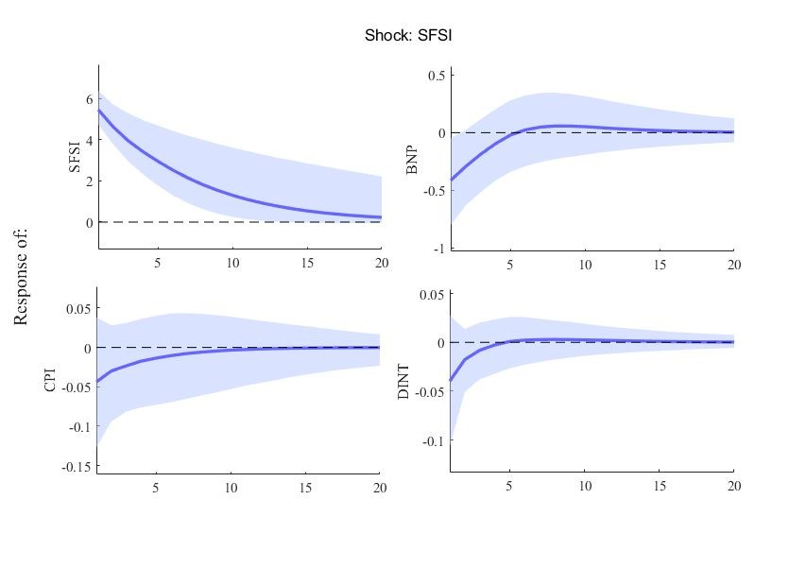

Figure 3: Impulse response functions from a shock to the SFSI index. Shaded area represents a 95% confidence interval.

which is reduced with a maximum effect of 0.04 units. All IRFs are presented in the Appendix in Figure 15.

In the historical decomposition in 4, we see the contribution of each structural shock to the historical dynamics of the variables meaning the historical value is decomposed into different components. We find that most of the historical fluctuations is contributed by the variables own shocks over time. During the period of the the great financial crisis in [årtal] and the euro crisis in [årtal] we see that the increased financial stress contributes to a large extent of the reduced GDP growth. The following period of normalizing financial conditions we also see that it attributes almost all of the GDP growth the following three quarters to the decreased financial stress conditions. In the later period of 2020, when the pandemic took place, we see that financial stress played little or no role in the reduced GDP growth. For the inflation rate we find that financial stress produces similar results as to GDP growth.

Forecast error variance lets us interpret how important a shock is in explaining the fluctuations of the variables in the model, it also allows us to see how the importance of a shock changes over time. From Figure 5 we can see that financial stress can explain very little of the fluctuations in the economic variables over all periods. For GDP growth the 5-6 percent of the variance is explained

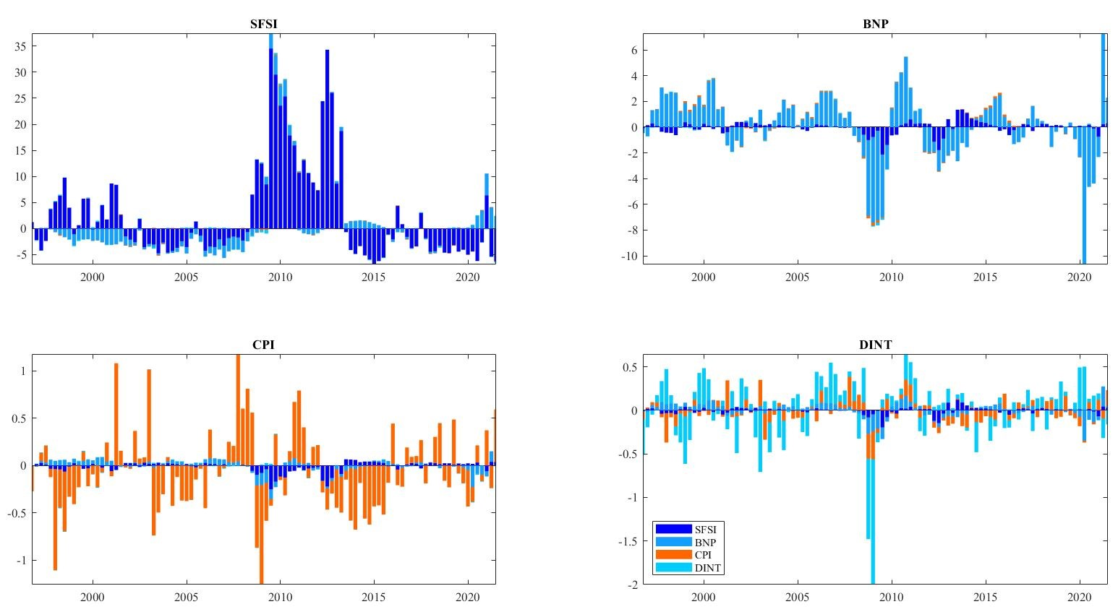

Figure 4: Historical variance decomposition of all variables. by shocks to financial stress.

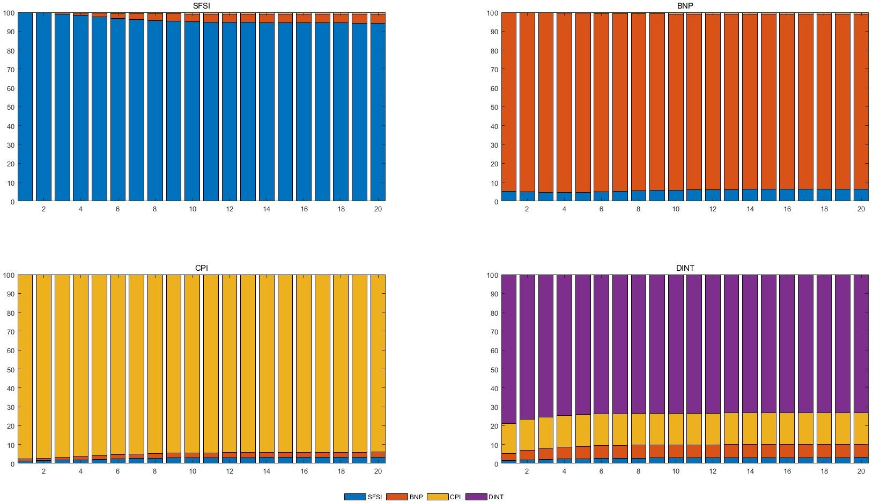

Figure 5: Forecast error variance of all variables, median percentage.

# 8 Sensitivity analysis

In this section I will present sensitivity analyses of the model, first by dropping the steady state prior to see if the IRFs are consistent and then use sign restrictions to see if the historical decomposition changes or stays consistent.

## 8.1 Normal diffuse prior

In Villani’s mean adjusted Bayesian VAR model one provides a informative prior, the steady-state values of the variables in the system. This assumes that prior information on the steady-state value exists for all variables in the system. This is however not the case for the financial stress index, where there is no prior theory on its steady state. To test the importance of the steady state for the results, assertion is made by estimating a traditional Bayesian VAR model,

**Π**(*xt*) = *α* + *et.* (9)

where **Π**, *xt* and *et* is defined as in Section 5. *α* is an *n*×1 vector of intercepts, where I set a diffuse prior *α* ∼ *Nn*(0*,*100*In*). I also set the prior mean on the first own lag to unity on all variables.

Given the above change on the model, I find that the impulse response functions in Figure 6 are exceedingly similar to those in Figure 15 and that Villani’s mean-adjusted Bayesian VAR does not affect the results.

## 8.2 Identification robustness

### 8.2.1 Changing ordering

To verify whether the results are robust or if they are sensitive to the recursive ordering of the Choelesky decomposition, one can estimate a new model with different ordering and see if there is significant difference in the produced IRFs. A common method to order economic variables is to order slow variables first and lastly fast moving variables. An example of this ordering is given by Stockhammer & Osterholm (2017) stating that this ordering is reasonable. Following their reasoning would in this case mean that the financial stress index changes daily taking new information into account, such as GDP, while economic variables such as inflation and GDP are sluggish and information from the financial

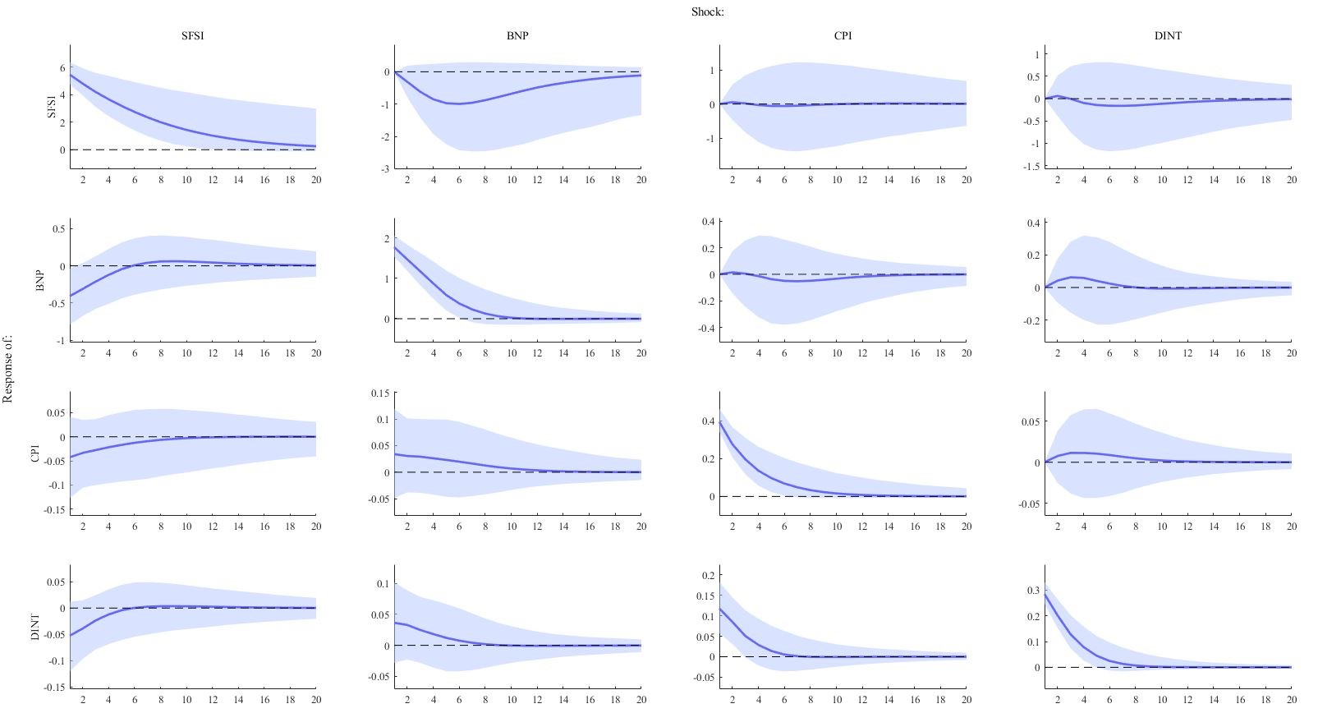

Figure 6: Impulse response functions normal diffuse prior. Solid lines are median response of the endogenous variables to one-standard-deviation shock. Shaded areas represent 95 percent error bands.

stress index is not taken into account by firms and consumers in the short term when making investment or consumption decisions.

This results in below order,

*xt* = (*y π* ∆*i SMSI*)*,* (10)

where *SFSI* variables is ordered last entails it does not have a contemporaneous effect on any other variables in the system. The IRFs produced from this model in Figure 7 shows no significant effect on GDP growth from a shock to financial stress compared to the original ordering of the model.

### 8.2.2 Sign restrictions

In Section 4.3 the identification for the model using sign restrictions was made. Using this identification resulted in similar results as the Choelesky identification from a positive shock to financial stress. The difference being that all economic variables having a significant response, with both greater magnitude and over a longer horizon. From Figure 8 we can see that the response of GDP growth from a positive shock to financial stress had a maximum reduction of 0.84 percentage points a period after the shock and that the effect faded away over 8 periods. Besides GDP growth, both inflation rate and change in interest rate has a significant decline after the shock compared with previous structural

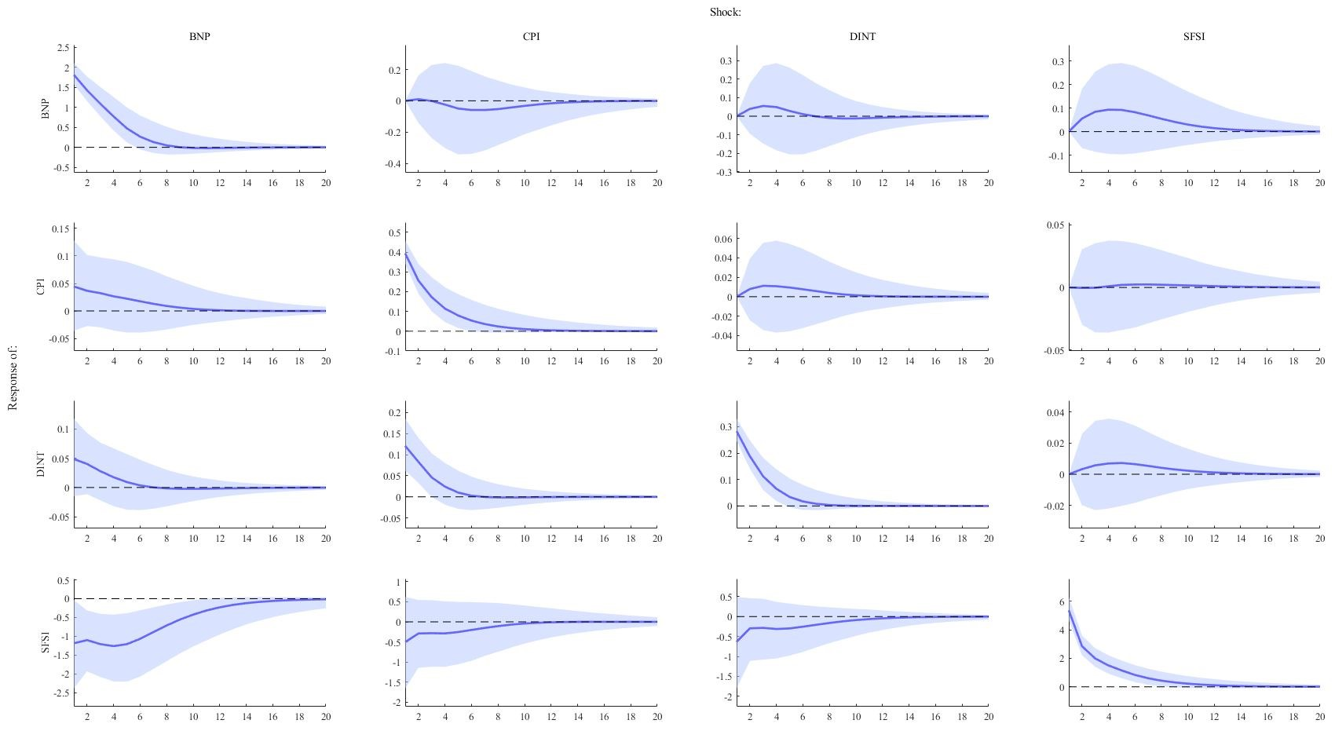

Figure 7: Impulse response functions SFSI ordered last. Solid lines are median response of the endogenous variables to one-standard-deviation shock. Shaded areas represent 95 percent error bands.

identifications. From the forecast error variance in Figure [FIG REF], financial stress shocks are shown to explain up to 30 percent of the variations in GDP growth, staying stable over all periods, where the increased explanatory power of financial stress is true for the other economic variables as well. In the historical decomposition financial stress is shown to be a key contributor in the fluctuations of the economic variables during the buildup and climax of the great financial crises.

# 9 Discussion

Dropping the steady state prior did not affect the results significantly. Altering the ordering of the variables, following a slow-to-fast specification where the financial stress index is ordered last, resulted in no significant response in any of the economic variables from a positive shock to financial stress. Comparatively with the original ordering in Equation 1, where a positive shock to financial stress had significant effect on GDP growth. Stockhammar & Osterholm (2017) found similar results when checking for the robustness of their model studying uncertainty shocks given by CBOE S&P volatility index.

Since ordering of the variables impacted the results, and specifically resulted in no significant responses from any of the economic variables from a shock to financial stress, this implies that the structural shocks are sensitive to the

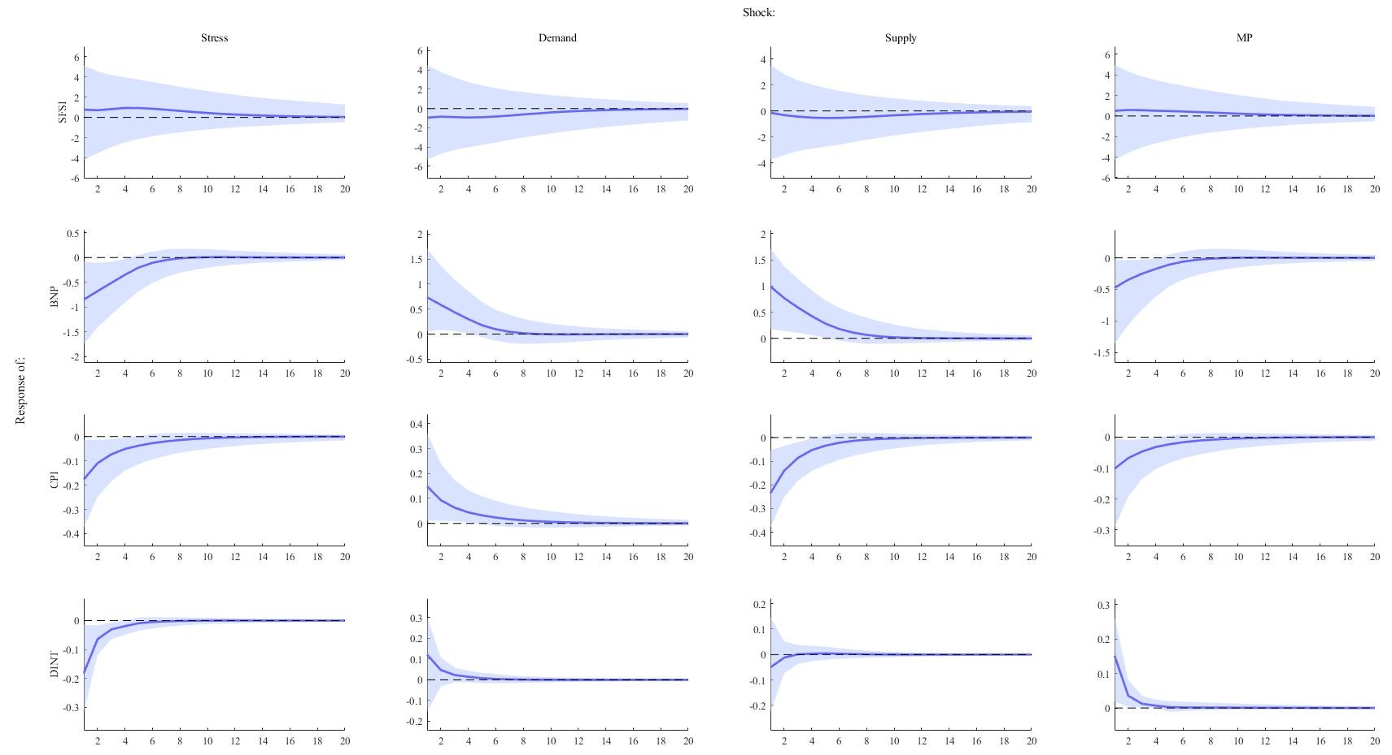

Figure 8: Impulse response functions SFSI ordered last. Solid lines are median response of the endogenous variables to one-standard-deviation shock. Shaded areas represent 95 percent error bands.

assumptions of the dynamics in the system and that a choice between the models is ambiguous.

Applying a different identification strategy, mainly sign restriction allow us more flexibility. The advantage of sign restrictions is not having to specify the recursive ordering of the variables. From this identification the effect of a positive shock to financial stress had greater magnitude and faded slower compared with the model using the Choelesky identification. The results from the restrictions were not tested for robustness and Fry & Pagan (2009) points out that sign restrictions is rather weak and should be used in conjunction with parametric restrictions. They also point out that both sign restrictions and recursive ordering only solves the structural identification but not the model specification.

Other identification method that are more widely adopted, such as narrative shocks and high-frequency identification and external instruments (Proxy SVAR), can be used to provide exogeneity. The challenge using these methods respectively is constructing narrative series and identifying events or having available data. For external instruments, the challenge is having an instrument fulfilling the relevance and exogeneity condition. In this case, that would be an instrument that is correlated with financial stress as well as uncorrelated with other structural shocks, meaning demand, supply and monetary policy shocks. Hence, finding a strong instrument can prove to be extremely challenging.

Another approach one may have in the interest of further studying financial stress, would be to investigate the interaction effect of financial stress as to estimate the simultaneous interaction between financial stress and macroeconomic variables, which can be made using an Interactive Panel VAR model which is a nonlinear framework. This method allows for suggestive answers to questions as to how great the fiscal multiplier is during periods of high financial stress or the effect of monetary policy when there is high financial stress.

# 10 Conclusions

The purpose of this study was to investigate the dynamics between shocks to financial stress and the Swedish economic variables such as GDP growth, inflation rate and interest rates using a mean-adjusted Bayesian VAR model specification. The main finding is that a positive shock to financial stress leads to negative GDP growth over five quarters where the maximum effect is 0.41 percentage points after the shock. From the forecast error variance 5-6 percent of the fluctuations of GDP growth could be explained by financial stress shocks. Other economic variables showed no significant response to a positive shock to financial stress. The results were not robust to a change in variable ordering, leading to all economic variables showing insignificant responses to a positive shock to financial stress. Changing identification strategy from Choelesky to sign restrictions showed that financial stress shocks having a greater contribution to the historical fluctuations in the economic variables and up to 30 percent of variations in GDP growth could be explained by shocks to financial stress from the forecast error variance.

**11 References**

# 12 Appendix

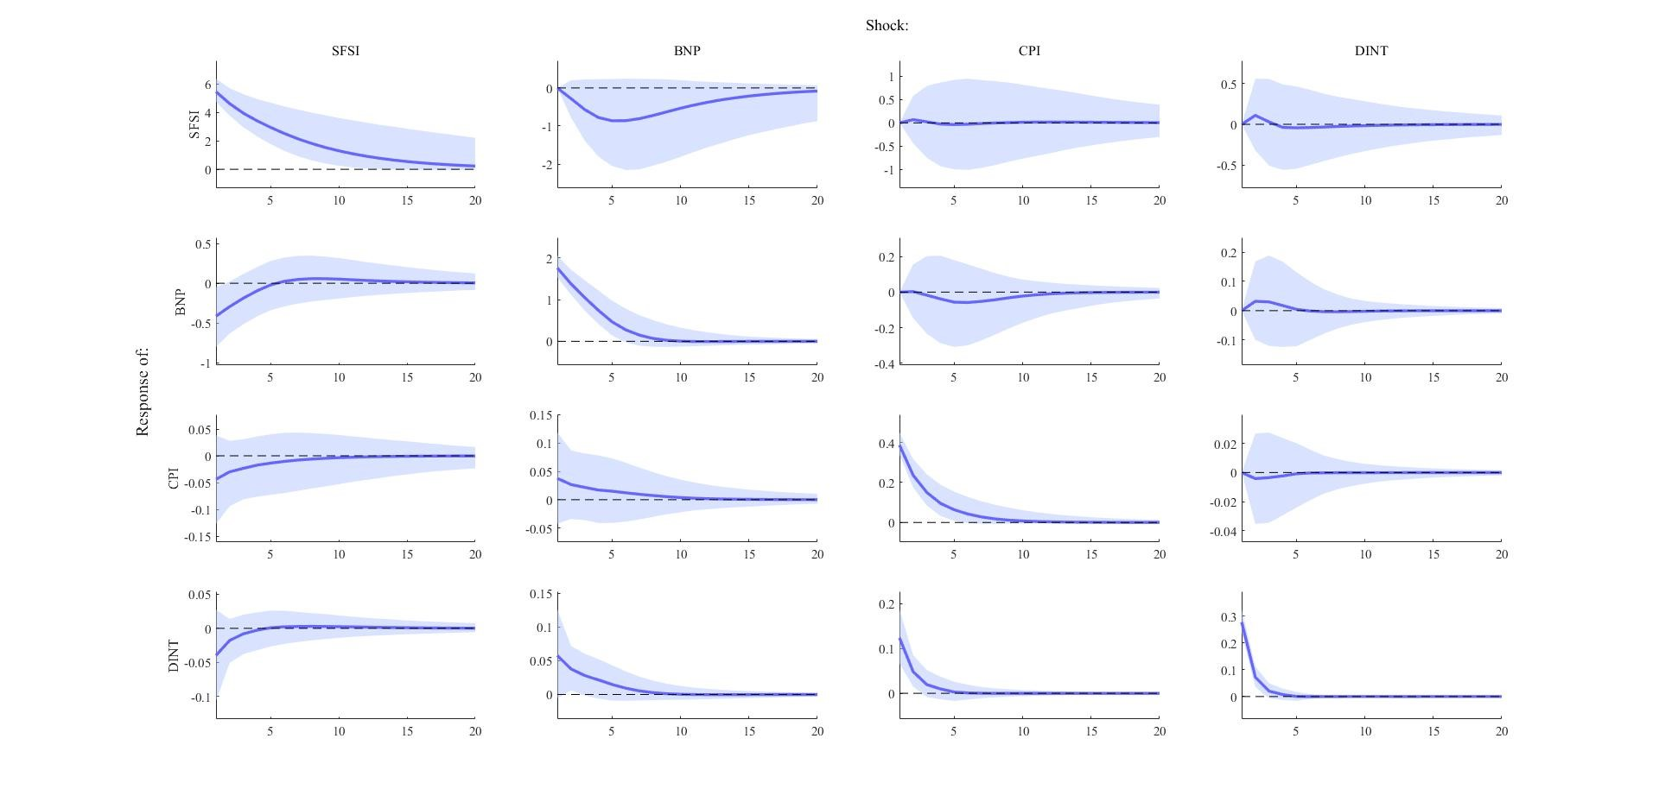

Figure 9: Impulse response functions mean-adjusted model. Solid lines are median response of the endogenous variables to one-standard-deviation shock. Shaded areas represent 95 percent error bands.

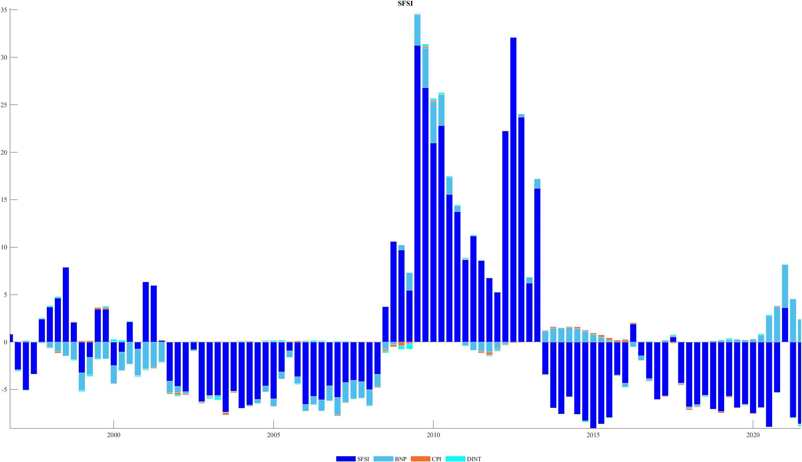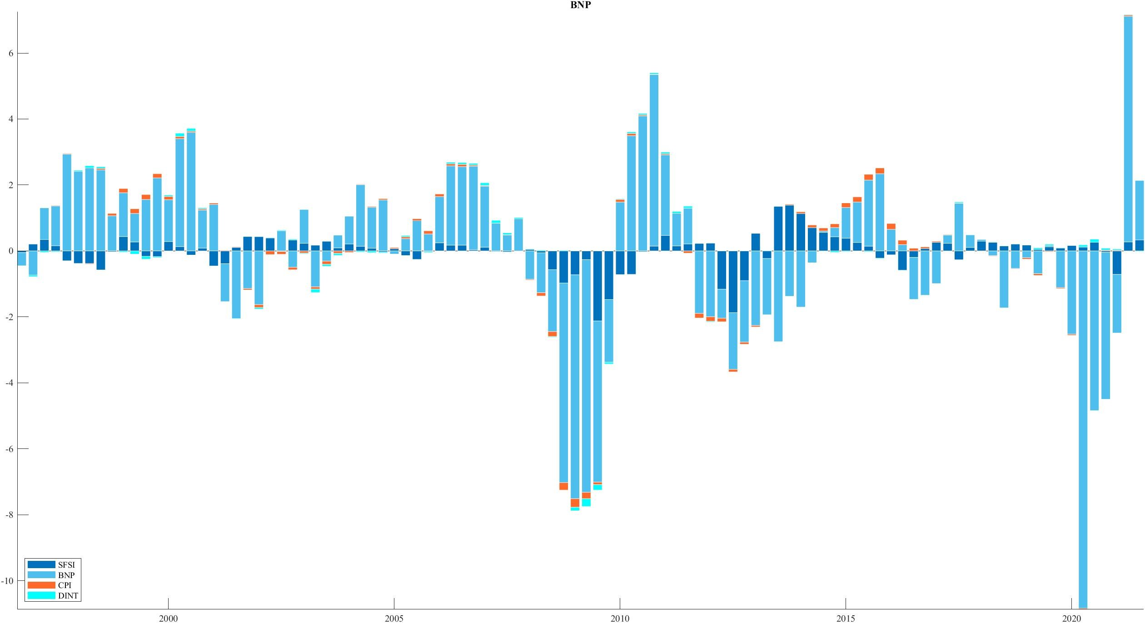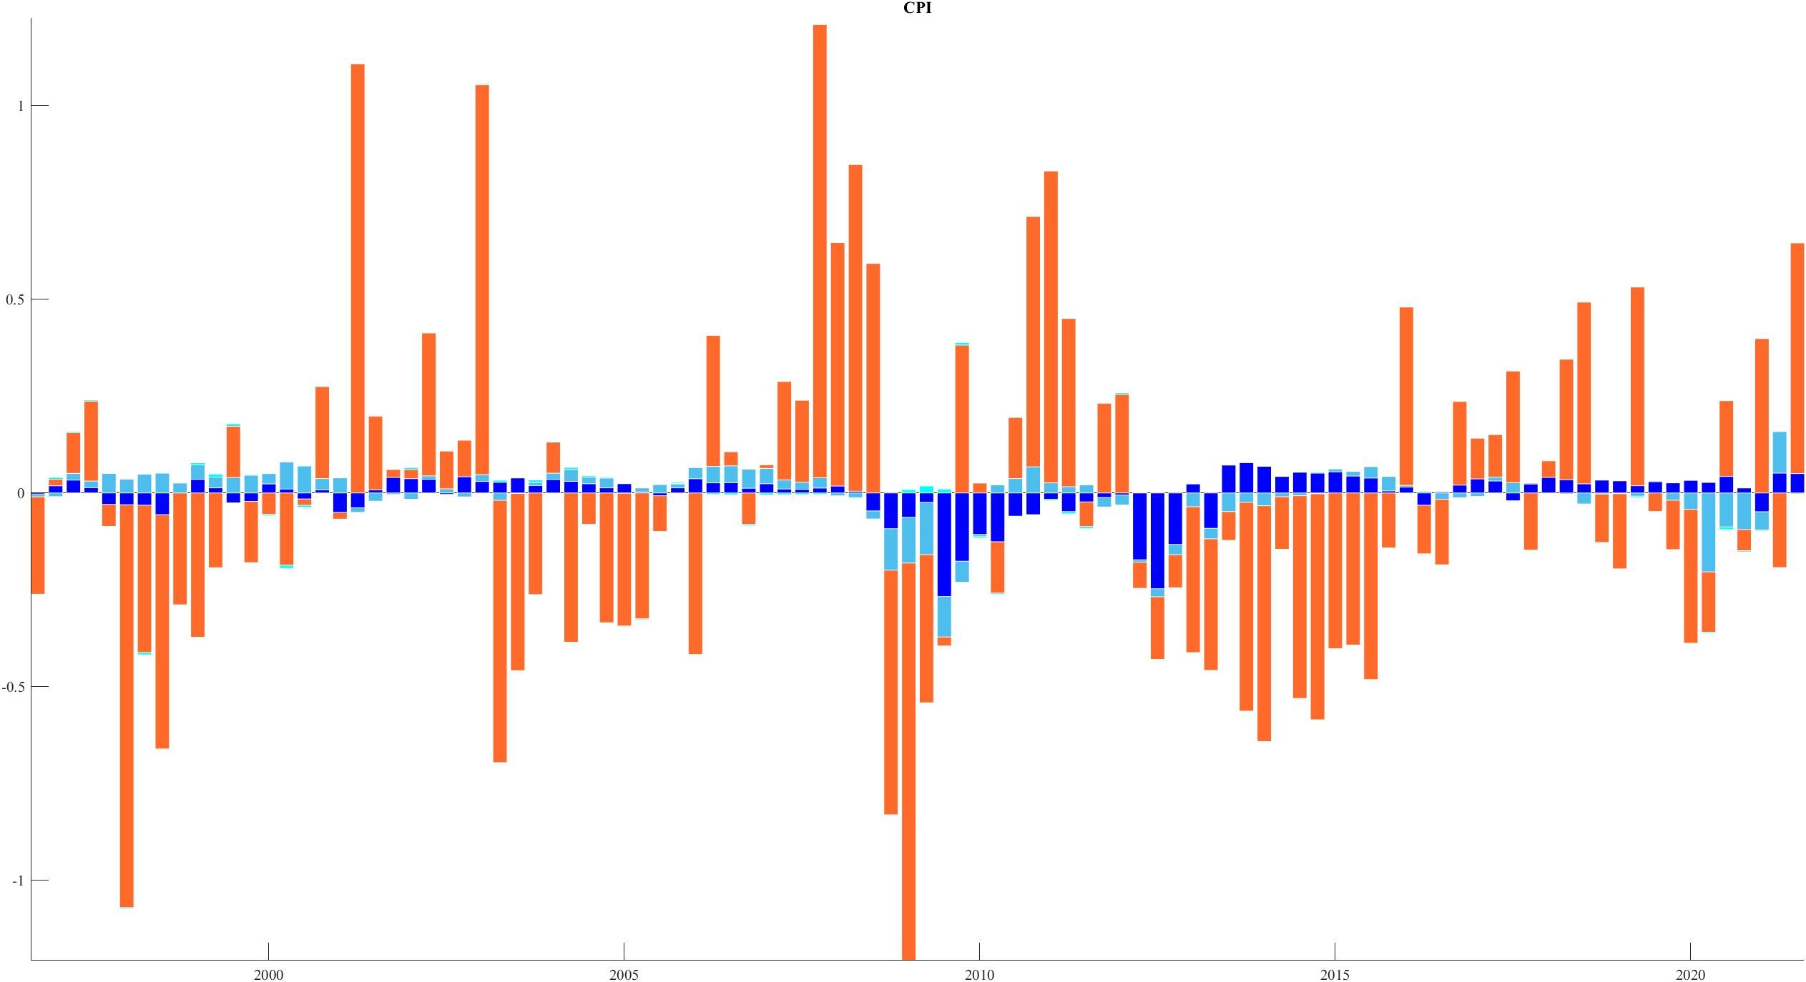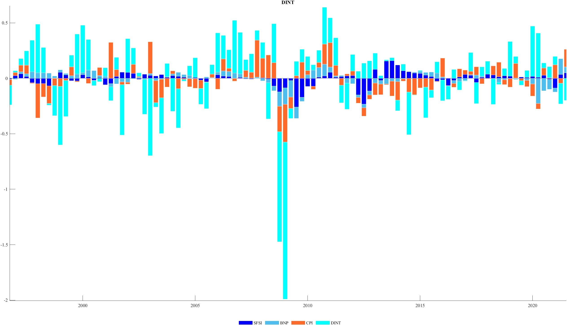

Figure 10: Historical decomposition normal diffuse prior.

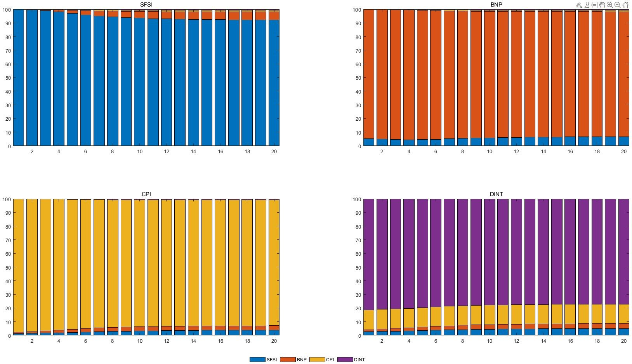

Figure 11: Forecast error variance normal diffuse prior.

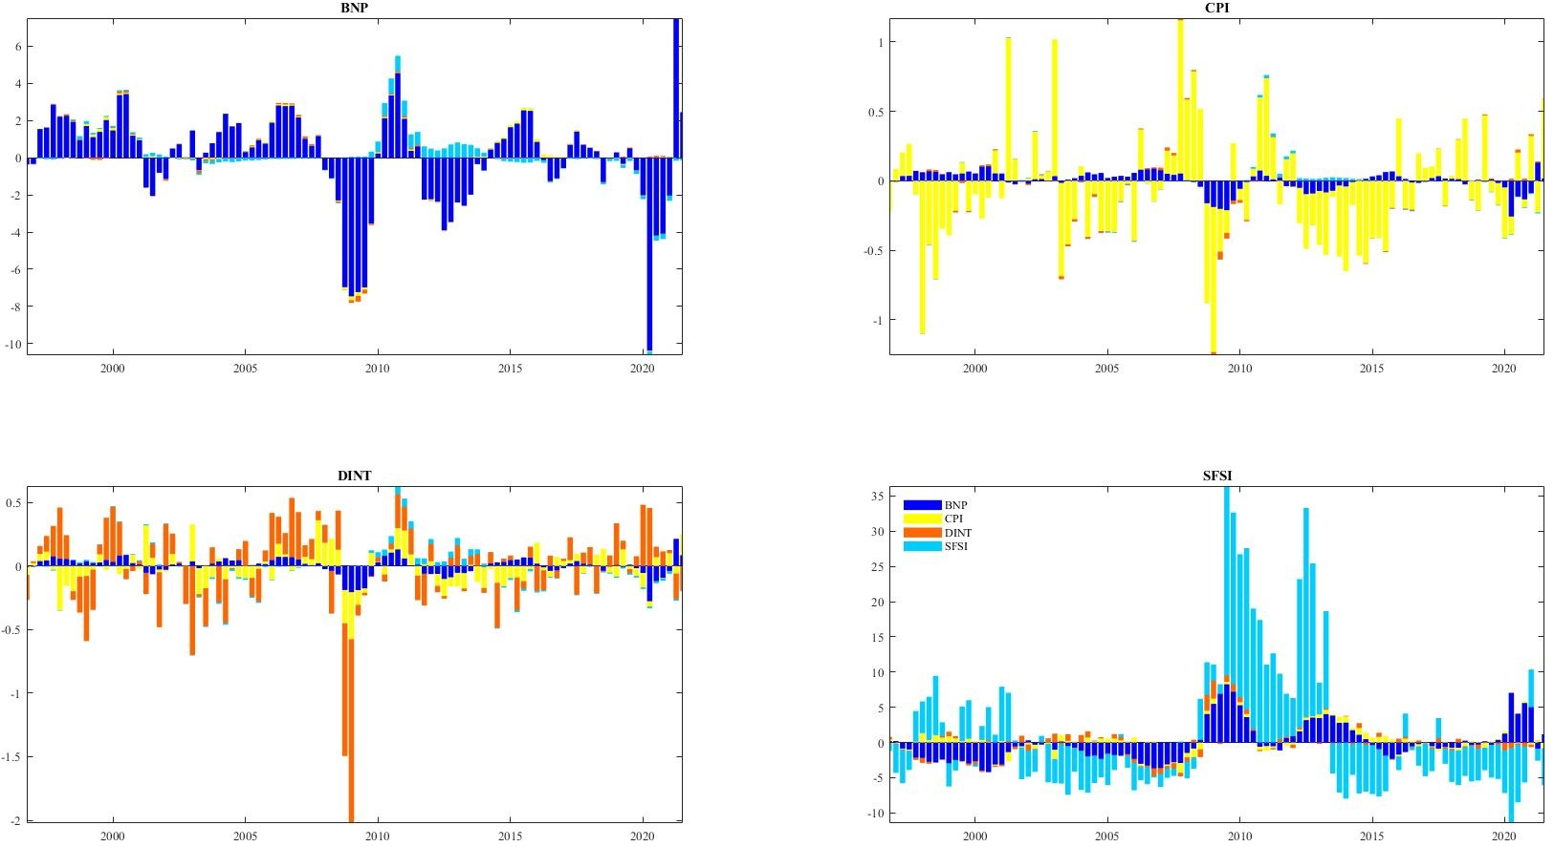

Figure 12: Historical decomposition *SFSI* ordered last.

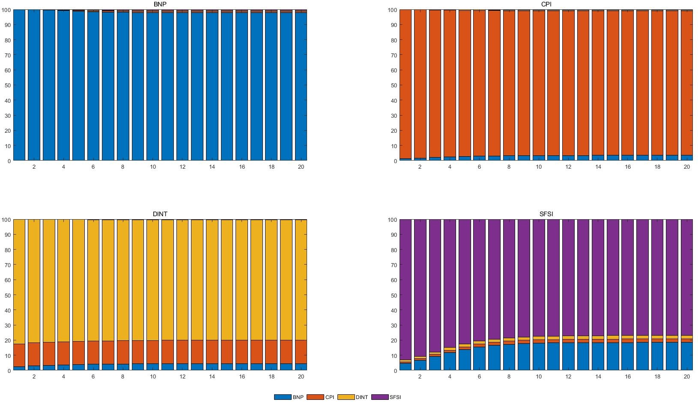

Figure 13: Forecast error variance *SFSI* ordered last

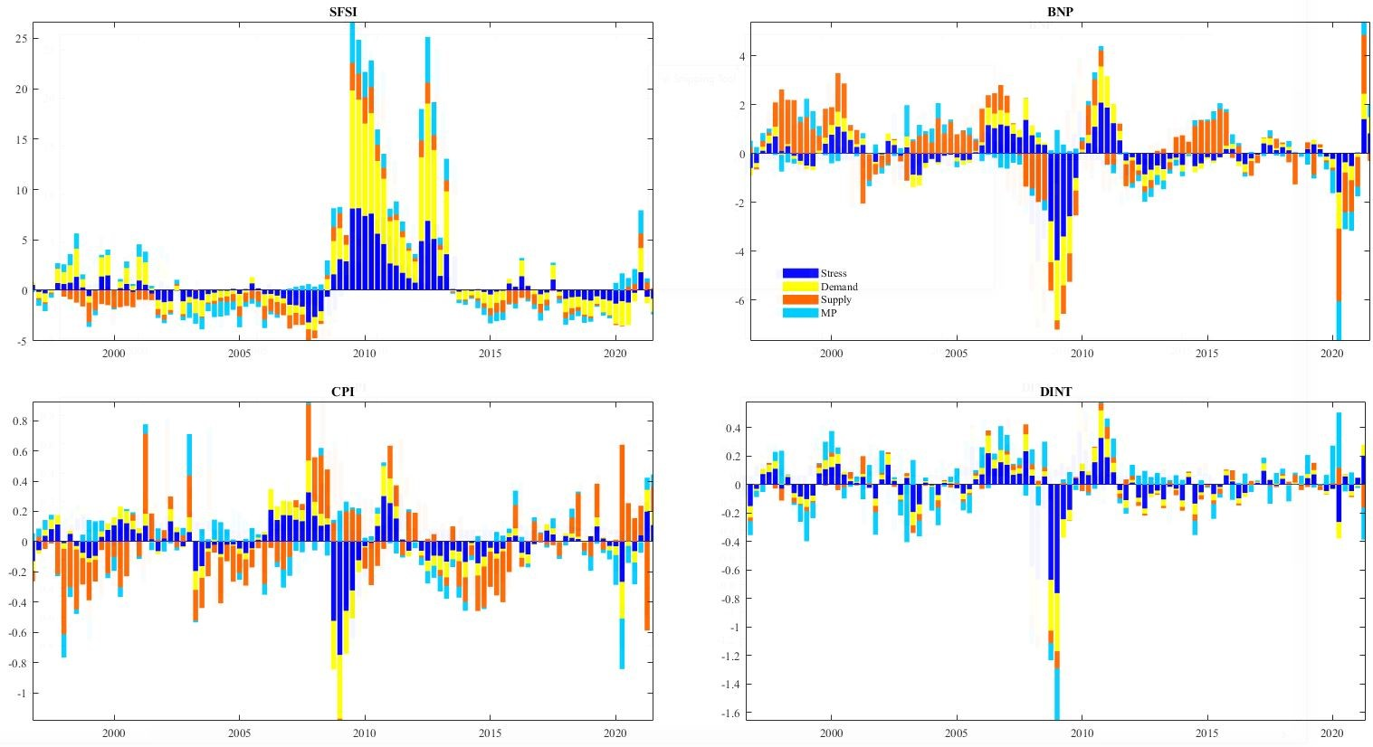

Figure 14: Historical decomposition, sign restrictions

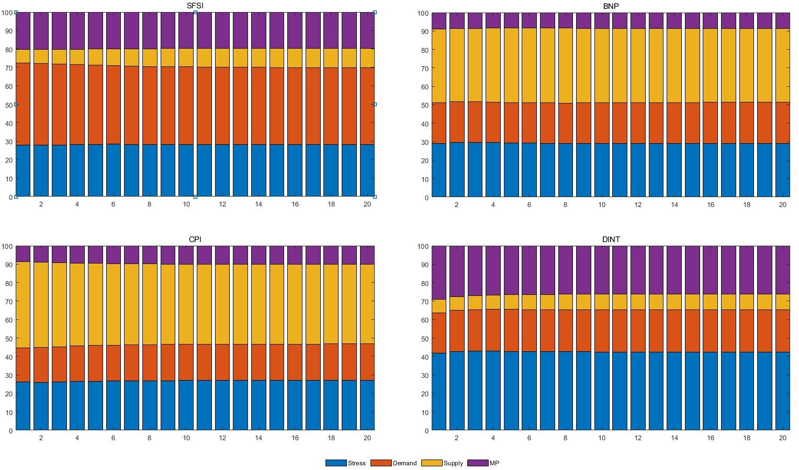

Figure 15: Forecast error variance, sign restrictions.